**Software Engineering Challenge**

**Phillip Sajaev**

**Requirements**

Describe the challenge or problem, what does the program need to do

Need to create a city viewer that will display a city and it has to be animated

What classes/objects do you think you need?

1. City Scape
   1. Building class
   2. City class
   3. Complex, more classes
2. Multiple Buildings
   1. Building must have windows
3. At least one animation

How much time do you think you will you need to complete the project?

I think that I will need to take at least 1.5 weeks and probably a weekend in order to finish this project and finish all of it with the requirements. It is a very difficult thing to do for my skill level in programming

**Research**

What knowledge or skills will you need to build this program

* You would need to know a fair amount about classes and object oriented programming. In addition, you will need to be able to effectively organize and store all the code that you have so that it runs efficiently. You will need to know how to use components or how to use Applet for the graphics part of it

What examples are online or in other graphical programs (games, apps etc. . .)

        If so, what can you learn from them?

* Some example of other graphical program would be all video games and many apps that would be good examples of how you can store all your code. I don’t really know what you could learn from these video games though.

Do you foresee any problems or constraints, describe

* It will be difficult to make sure that the colors are being painted on at the correct times and that nothing is being painted over by something else. Also, making the animations will be difficult because I will have to repaint it after each frame.

Have you created a similar programs or applets? Are there similar programs in the book or other resources?

* A similar program to this would be the File IO program in addition to Shepard Fairey. They were both challenging programs that required using Paint Components and classes in order to make it run. The book also offers advice after every chapter on how to use the material you learned in order to make an Applet with it

If so, what elements of that project can you bring to this project?

* Both require that you use the paint component in addition to being able to use classes and objects. Also, I would have already been familiar with the applets that I’m using.

Do you have the resources you need to create the program?

* I have the Internet at my fingertips, I don’t need anything else

Do you need to learn any new knowledge or skill(s) to create the program?

* I will have to learn how to use an applet and learn the basics as to how it works and how to use paint with it. In addition, animation is a new skill that I will have to learn

**Design**

Draw/create a basic graphic of the applet you plan to build - attach the drawing

(paint, word, photo shop) not every object (draw one example although there may be several in the final program) needs to be in the basic graphic

Include a task list--what will you need to do and in what order

Estimate the amount of time you will need to complete the project

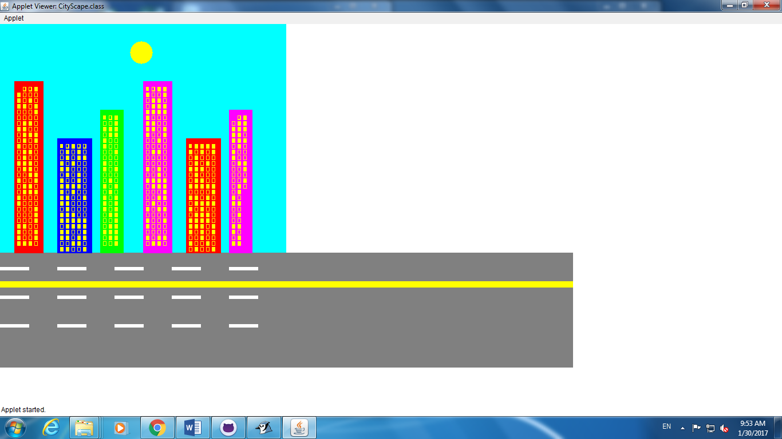

**Construction – included in summary doc**

Document your construction progress with date and progress made (build a chart/table in word or excel), also, include at least three screen shots of your applet (beginning, middle, and end)

* This is a screenshot of the final product, I didn’t take any screenshots while making it

**Testing/Results/Delivery—summary doc not required to start project**

Preliminary testing

Does your program meet the needs of the initial challenge or problem?  How do you know?

Are any changes or modifications needed, why or why not?  Document any changes.

Summarize the project - what worked, what didn’t work, note your successes and/or failures.

Looking back, would you have done anything differently, why or why not

Software Summary Document

My program meets the challenge of making an animated cityScape. My CityScape has 6 buildings with windows and it has a moving sun along with windows that flash randomly 60 times a second. Some modifications that I could probably make would be that at times, some of the windows don’t show up like is present in the screenshot. About half a column of windows are disappeared in the screenshot that I posted and I can’t figure out why. However, at other times, those windows will be there.

I was surprised at how easy it was to make the flashing windows flash randomly and how to make the sun animated. I was able to do both of these tasks quickly. I used a catch and try method for the sun and I used random numbers to determine whether the window should be lit or not. Something that I would like to change if I had to do it again would be that I repaint everything on every frame which would take up a lot of power on the part of the computer and it makes the CityScape look laggy overall.

Daily Progress Report

|  |  |
| --- | --- |
| Date | Description |
| January 19, 2017 | Sketched out my design in paint, worked on engineering document |
| January 20,2017 | Did the sun, also worked on engineering document |
| January 23, 2017 | Started to make out basic buildings , started to make the windows |
| January 24, 2017 | Made the buildings and also did the loop for making the right amount of windows |
| January 25, 2017 | Made the ground class, added a brown layer on the bottom of the buildings |
| January 26, 2017 | Made the street class, added rectangles to make the ground look like a street that cars drive on |
| January 27, 2017 | Colored in the windows yellow and also made it so that the buildings are different heights but the windows still are formatted correctly |
| January 29, 2017 | I figured out how to make a background on the JApplet and I also worked on the engineering document and the Software Summary document |
| January 30, 2017 | I finished the Engineering Document today and made revisions to it |
| January 31, 2017 | Looked over the program and added comments to places where the code is confusing |